**PROJECT REPORT**

Modern Application Development I

Influencer Engagement and Sponsorship Coordination Platform

**Author:** Kritika

**Email:** [23f1001523@ds.study.iitm.ac.in](mailto:23f1001523@ds.study.iitm.ac.in)

**Project Statement :**

It's a platform to connect Sponsors and Influencers so that Sponsors can get their product/service advertised and Influencers can get monetary benefit.

**Technologies Used :**

* Python
* Flask
* Flask SqlAlchemy
* Jinja2 templates
* Bootstrap for HTML generation and styling with CSS
* SQLite for data storage
* Chart.Js

**Database Schema :**

The Database schema comprises following Classes/Entities:

1. **Admin** - Stores Admin details and attributes such as Id,Name,Password.
2. **Sponsor** - Stores Sponsor information such as Id,Name,Industry,Budget,Status(Active/Inactive).
3. **Influencer** - Stores Influencer information such as Id,Name,Category,Niche,Reach,Status(Active/Inactive).
4. **Campaign** - Stores Campaigns created by Sponsors having fields such as Id, Name,Description,Start_Date,End_Date,Budget,Visibility (Public, Private),Goals,Expiry,Status(Active/Inactive).
5. **AdRequest** - Stores Adrequests created for a particular Campaign having Campaign_id (Foreign Key to Campaign table),Influencer_Id (Foreign Key to Influencer/user table),Messages,Requirements,Payment_Amount,Status (Pending, Accepted, Rejected) ,Flag_Status(Active/Inactive).
6. **Negotiations** - Stores Negotiations sent by Influencers for AdRequests of Public Campaigns having fields such as Influencer_Id,AdRequest_Id,Negotiations.

**ER Diagram :**

The Entity Relationship Diagram below shows the DataBase Schema and relationship:

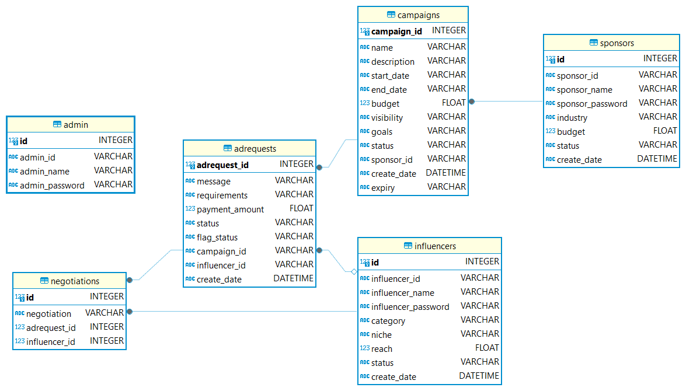

**Architecture Design :**

The Model View Controller-MVC architecture has been implemented in this project. The project has following structure:

1. **Controllers** - Contain controllers for Admin,Sponsor,Influencer,UserManager.
2. **Templates** - Contain all views divided into further sub-folders for clarity.
3. **Models** - Contain model.py defining classes for model as per schema.
4. **Static** - Contains CSS.
5. **Database** - Contains sqlite database file.
6. **Application** - Contains config file.

**Main features and Working :**

The project has separate login and registration for Sponsor and influencers

**Admin Controls:**

* An admincan monitor all the users/campaigns.
* The Dashboard is provided with all the relevant Statistics.
* Ability to flag inappropriate campaigns/users.
* Multi Level search of Sponsors/Influencers/Campaigns/AdRequests based on various criteria.

**Sponsors:**

* Sponsors can update and modify their profiles.
* They can create and modify the Campaigns.
* Sponsors can create multiple campaigns and track each individual campaign.
* Search Influencers on different parameters
* Send Ad Requests to particular Influencers for Private Campaigns.
* Accept or reject requests of Influencers for Public Campaigns.

**Influencers:**

* Influencers can update and modify their profiles.
* Receive and Negotiate on AdRequests by Sponsors for Private Campaigns.
* Can negotiate by sending a response to AdRequests for Public Campaigns.
* Search for Public Campaigns and AdRequests according to different criterias.

**Video Link :**

<https://drive.google.com/file/d/1lQTz3xGPg-6tj3jJJQ1UhMEAnFikdxwR/view?usp=sharing>